assignment #05

Course: CHE 341: Chemical Process Control
Term: Spring 2026
Professor: Dr. Michael Caracotsios
Office: EIB 244

Cell Phone: (630) 696-0934
E-mail: mcaracot@uic.edu

Name: ______________________________
Due Date: Friday, April 10th TA’s Mailbox

INSTRUCTIONS FOR ASSIGNMENT DELIVERY

- Prepare a typed report of your assignment.
- Include this cover page with your name in the report.
- Upload your report as a PDF file by the Due Date and Time(6:00PM) on the UIC Blackboard.
- Place a hard copy of your report as a PDF file by the Due Date and Time(Closing of the Business Day) in the TA’s mailbox.

- Assignments that are not typed will not be accepted.
- Late Assignments will not be accepted without prior approval.
- You may use the Internet as well as ChatGPT or other public tools as long as you place a written statement about their use in your assignment report

Problem A: Empirical Model Building

Construct the process transfer function from the multiple step test commercial data contained in the accompanying Excel file: Assignment-05.xlsx

Problem B: Process Control Loops and Measurement Devices for Split Range Control

A process diagram for the control of a batch reactor is shown in the Figure below:
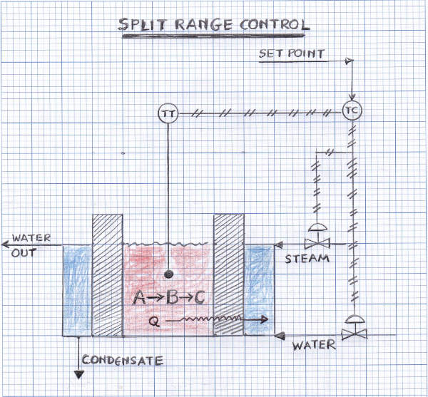

The size of the batch reactor(red color), the metal wall thickness(black pattern) and the jacket thickness(blue color) are not drawn to scale. The objective of this assignment is to control the production of a specialty chemical compound that takes place in the batch reactor. The specialty chemical is produced by the following reactions, with the adjacent kinetic data:

Batch processes offer some very distinct and challenging control problems. In a typical scenario (like the one in this assignment) the reactants are charged in the reactor which also may contain a solvent and the reactor temperature is raised by using a temperature controller that controls the flow rate of steam in the jacket of the rector (see Figure above). Once the temperature reaches the desired point, the controller shuts down the steam valve. At this point the chemical reactions are initiated either by charging a catalyst or simply because of the high temperature. If the chemical reactions are exothermic the temperature will begin to rise. This can be detrimental to the product as well as the catalyst. To avoid a large temperature rise, the temperature controller will now open the water valve and start manipulating the water flow rate, to keep the reactor temperature at a specified set point. This is known as split range control.

Set points for the temperature are pre-calculated by performing optimization studies which are designed to maximize the production of the specialty chemical. Most of the time the set point varies with time and this variation is calculated by the nonlinear optimizers. In our example the set point has been pre-calculated and is given below. To control the temperature at its set point you will design a proportional controller. Your objective would be to make as much product as possible, keeping the process stable and avoiding large oscillations in the temperature and the water flow rate. Large water flow oscillations result in wear and tear of the valve. The following data are available for you to conduct your studies:

Cooling water is available at 80 ºF. The temperature sensor(thermocouple) has a time constant equal to τ_{s}=1 min. The temperature transmitter sends a pneumatic signal to the temperature controller. The pneumatic signal range is [3 psi – 15 psi]. The reactor temperature range is [50 ºF - 250 ºF]. The water valve is linear and has been sized with Cv=100 gpm (psi)^{-0.5}[fully open]. The pressure drop across the valve is constant and equal to 20 psi. The valve is fully closed at a pressure signal of 9 psi and fully open at a pressure signal of 3 psi. The steam valve is also linear and has been sized to give a valve coefficient Cv=112 lb/min (psi)^{-0.5}[fully open]. The pressure drop across the valve is constant and equal to 0.2 psi. The valve is fully closed at a pressure signal of 9 psi and fully open at a pressure signal of 15 psi.

The controller has a bias of 7 psi and its output signal is given by

where TT is the temperature transmitter signal in psi and SP the set point in psi. The set point has been calculated via optimization and it is given by:

The total time of the batch process is 60 min. Use the 5th order Runge-Kutta method with Total Number of Solution Points=200 and Number of Steps between Solution Points=1

The following tasks are required of each team

- Prepare the dynamic model for this batch process. You may neglect the dynamics of the steam (but not of water) in the jacket. The reactor metal wall must also be included in the energy balances. Include a description of all symbols that you have used. The mass and energy balances must be written clearly for the three phases of the specialty chemical production, i.e.,

  - Heating phase using dry saturated steam from a 35 psia steam header flowing through the reactor jacket
  - Cooling phase using cooling water filling the reactor jacket
  - Operating with jacket full of water.

- Solve the differential equations using the CHE Calculator and prepare plots of the reactor temperature for controller gains Give a brief description of what you are observing as you increase the controller gain. Include an Appendix in your report with the Visual Basic code of your model and the excel worksheet with your data and the plots.

- Investigate the use of PI controller to eliminate the offset and propose a value for the controller gain and the controller rest. For these values create a plot for the reactor temperature as a function of time.

